PRACTICAL - 3

DATE: , Wednesday

AIM: To compare OSI and TCP/IP protocol model

* **OSI model** 
  + The OSI (Open Systems Interconnection) model categorizes the functions of communication systems into seven layers, each addressing specific tasks to facilitate interoperability and structured network design.

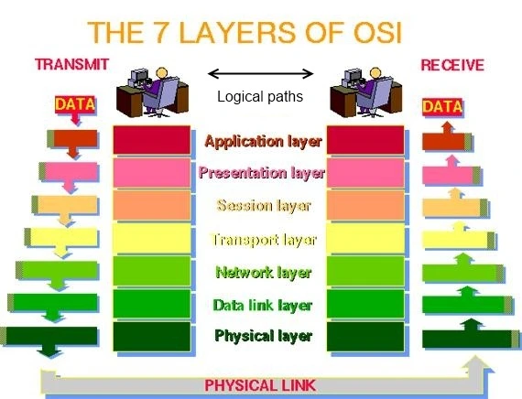

* **TCP/IP Model** 
  + The TCP/IP (Transmission Control Protocol/Internet Protocol) model is a foundational networking framework that combines functionalities into four layers: Application, Transport, Internet, and Link. It serves as the basis for communication over the Internet, facilitating data transmission and ensuring compatibility across diverse network architectures.

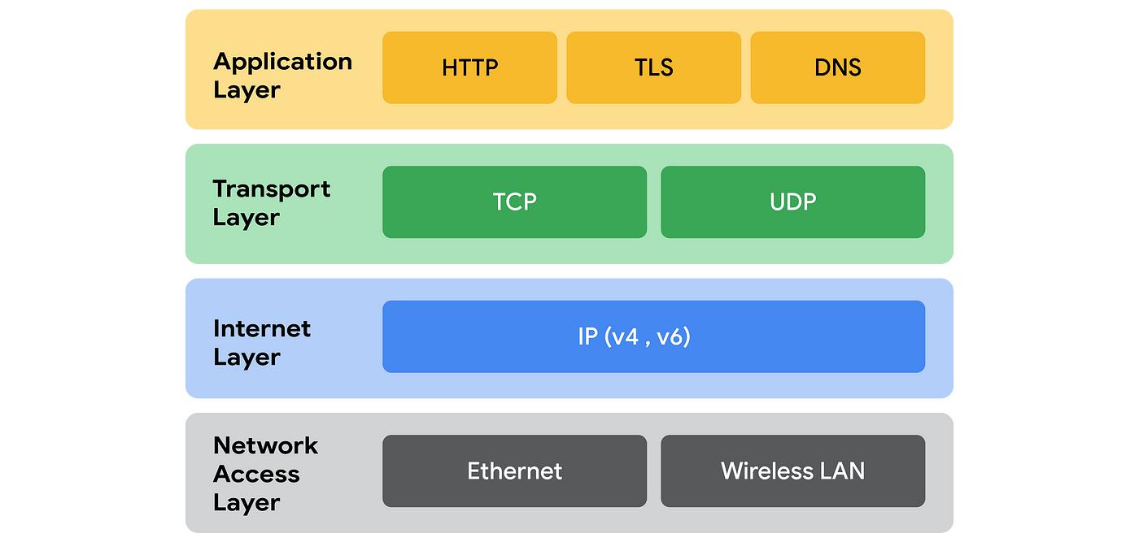

|  |  |  |
| --- | --- | --- |
| Aspect | OSI Model | TCP/IP Model |
| Layers | Consists of seven layers: Physical, Data Link, Network, Transport, Session, Presentation, Application. | Combines functions into four layers: Application, Transport, Internet, Link. |
| Development | Developed by ISO (International Organization for Standardization). | Developed by ARPANET (Advanced Research Projects Agency Network) and later standardized by IETF (Internet Engineering Task Force). |
| Standardization | A conceptual model, not a protocol suite. | Both a model and protocol suite widely used in networking. |
| Flexibility | More flexible and modular, allowing for broader application across different network architectures. | More streamlined and directly applicable to Internet networking. |
| Interoperability | Provides a structured approach to ensure interoperability between different vendor systems. | Emphasizes interoperability across heterogeneous networks and systems. |

Date of Submission: Sign:

______________________ Mr. Jigar Patel